**Kubernetes Task-2**

**Task Description:**

Create the K8s EKS,further you have to do the deployment of the Nginx application and access the application outside the cluster

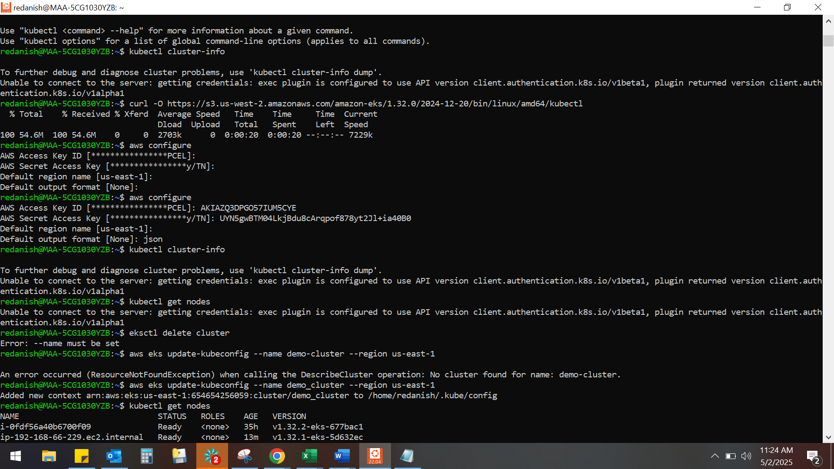er.

